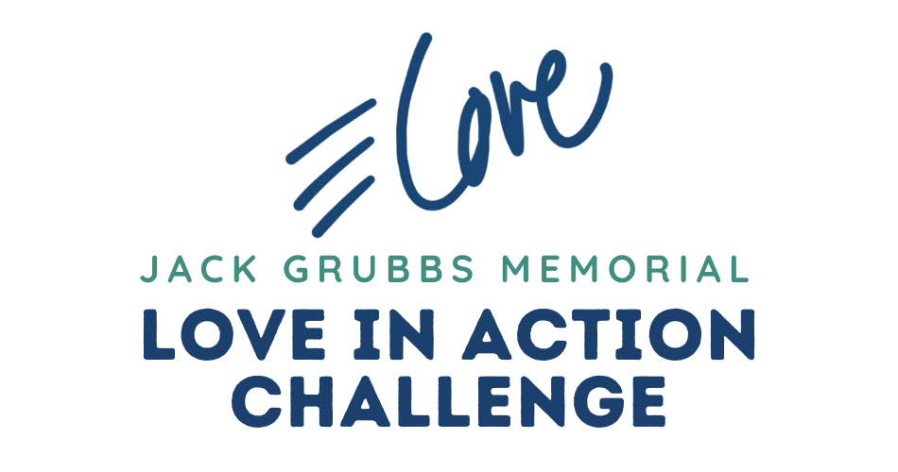

I HAVE ACCEPTED THE LOVE IN ACTION CHALLENGE.
WILL YOU SPONSOR ME?

Dear Friend,

I will be [running, walking, swimming, biking…] 26.2 [miles, laps, days…] during the month of May to raise money for children with albinism who are served by an organization called Shade (shadetz.org). I am looking for friends and family who will sponsor me by the [mile, lap, day] or just donate to my cause. My goal is to raise $[ ] by May 31.

This event honors Jack Grubbs, Shade’s former Chairman of the Board, who passed away in November. Jack was an avid runner and always ready for a challenge.
He [was my friend and] was deeply involved in the mission to serve and advocate for those with albinism in Tanzania whose lives are at risk due to dangerous witchcraft beliefs. The money raised will go toward building a cafeteria at Shade School to promote the health and safety of the kids.

Visit my site at [site address] to learn more. I will post updates of my progress there and on social media. Payment of pledges can easily and safely be made right there on my page as well.

So please help me promote the health of vulnerable kids in Tanzania and jumpstart my own summer fitness by sponsoring me in the Love In Action Challenge. I’m anxious to hear from you!

Text:
Email:

